**CURRICULUM VITAE**

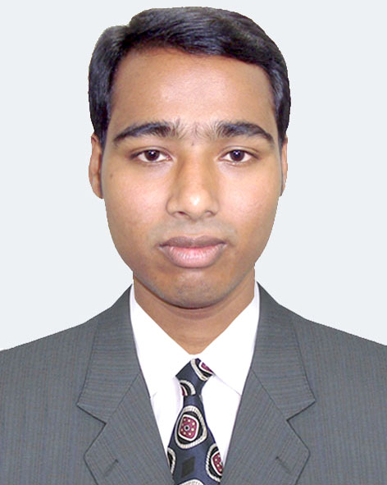

Of

**Muhammad Ekbal Hossan**

Village:Eklashpur, P.O:Eklashpur Bazar

Upazilla:Begumgonj, Dist: Noakhali,

Mobile: 01955957354

**Objective** : To build up a respectable career in a reputed institute where I can be able to prove my competence.

**Attributes** : 1.Proficient in the use of computer.

2. Effective in maintaining good communication with others.

3.Thirst for challenges.

**Education** **M.A (Islamic Studies)**

University : National University

Institute : Dhaka College

Year : 2013 (Studding)

**B.A (Honours)**

University : National University

Institute : Noakhali Govt. College

Year : 2012

Result : First Class

**Higher Secondary Certificate(Alim)**

Board : Madrasah Board

Group : General

Year : 2008

GPA : 3.83

**Secondary School Certificate(Dakhil)**

Board : Madrasah Board

Group : General

Year : 2006

GPA : 3.50

**Computer** : I have successfully completed Training course in MS Office Program.

**Language** : Bengali : Excellent

**Proficiency** : English : Good

**Hobbies** :Reading books,Internet browsing and Travelling.

**Personal Details:**

Father’s Name : Muhammad Abdul Wohab

Mother’s Name : Anowara Begum

Present Address :C/O: Komor Uddin Hazi Bari, Village:Eklashpur, P.O:Eklashpur

Bazar, Upazilla:Begumgonji, Dist:Noakhali

Permanent Address : As Above

Date of Birth : 17th July 1991

Nationality : Bangladeshi (by birth)

Religion : Islam

Marital Status : Single

Sex : Male

Home District : Noakhali

Mobile No : 01627527954

**REFERENCE :** Shajahan Khaondker

Mob: 01711838863

**Declaration of Authenticity**

|  |
| --- |
| I do hereby declare that all information have presented are true to my knowledge, If required and where applicable, this document can be supported by appropriate authentic certificates or papers. |

----------------------------------------------

(Muhammad Ekbal Hossan)

Date :